HKU SPACE Community College
Associate Degree / Higher Diploma Program
Second Semester 2022-2023

Introduction to Database System

Project Report

“Netflix Database”

Lecturer: Leo Tsui
Group Member:
- Li Chun Ip (20166772)
- Pang Ka Yin (20188944)
- Tung Pok Man (20186962)
- Yeung Man (20189102)
- Yip Chin Hei (20189599)
Class: 06
Submission Date: 12 April 2023
Words: 1892
Table of Content
1. Background 3
2. Scope of Project 4
2.1 Data Sources Used 4
2.2 Limitations of Study 4
3. Data Model 5
3.1 Entities 5
3.2 Business Rule in Figure 3.01 5
3.4 Constraint of these attributes 8
4. System Design 8
4.1 Entity Design 8
4.2 Normalization 11
5. Queries and Entities 13
5.1 SQL Queries 13
5.1.1 Company Perspectives 13
5.1.2 Customers’ Perspectives 20
6. Conclusion 24
6.1 Summary of key findings 24
6.2 Implications for Netflix 24
6.3 Suggestions for further research 25
8. Acknowledgements 25

1. Background

Netflix is a revolutionized media that consumes the landscape and the entertainment industry. Almost 208 million users in 190 countries can access the website to view television programs, films, and other content. Understanding the viewing habits of Netflix subscribers is important for obtaining insight into their preferences. Furthermore, the behavior of internet streaming has become increasingly popular and wider. Therefore, the objective of the study is to assist the platform in enhancing both the quality of its content and the user experience.

2. Scope of the Project

This project aims to analyze the viewing patterns of Netflix users and provide insights into the most-watched shows, average watch time per show, demographic distribution, and geographic distribution.

2.1 Data Sources Used

The data used in this study will be obtained from publicly available sources such as the Netflix API and publicly available datasets on Kaggle. The data will include information on the most-watched shows, average watch time, and demographic and geographic distribution of Netflix viewers.

2.2 Limitations of the Study

The study is limited by the availability and accuracy of the data used. The data obtained from the Netflix API may not be complete or up-to-date, and some information may be missing. Additionally, the results are not represented the entire fact because not enough sample of the overall Netflix user population was taken. Also, other factors that may affect viewing patterns, such as social and economic are not considered.

3. Data Model

3.1 Entities

To fulfilling the requirements, we have designed 7 related data models in a global view, with relative attributes, constraints, and relationships in the following (Figure 3.01).

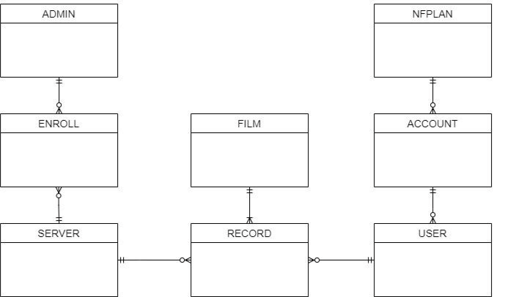
Figure 3.01 Conceptual Data Model

3.2 Business Rule in Figure 3.01

The data model shown has the following business rules:
- Many accounts have one subscription.
- A subscription contains many accounts.
- An account can create many users.
- Many users are created by one account.
- A user can have many records.
- Many records can be associated with a user.
- A film leaves many records.
- Many records are left in one film.
- A server owns many records.
- Many records are owned in one server.
- An admin may take up to a server through enrollment.
- A server is taken by many admins through enrollment.
3.3 Attribute in Figure 3.01

- ADMIN (Admin staff number, Admin first name, Admin last name, Admin email, Admin phone number, Admin position)
- This entity records some personal information and company information of admins. This is used to find if need to know the personal information of the admin who is managing the corresponding server.

- ENROLL (Corresponding admin, corresponding server)
- This entity is used to connect both SERVER and ADMIN, to distribute the server for the admin to manage. This is used to find which admin is managing which server, and which server is managed by which admin as well.

- SERVER (Server number, server country, capacity/storage of server, produce date of server)
- This entity records all the server details and status. This is used to know which servers are fully or seldomly used, and which servers need to upgrade or withdraw.

- RECORD (Film record number, corresponding user number, corresponding film number, corresponding server number, film last recorded date, film last recorded time)
- This entity saves all the film-watching records made by users. This is used to know the status of movie viewing, save the record for analysis and get the data.

- USER (User number, username, user age, corresponding account number)
- This entity records some user personal details. It is for data analysis.

- ACCOUNT (account number, account email address, account country, corresponding account scribed plan)
- This entity records the account information, it is for the admin to search and follow the account status.

- NFPLAN (Plan number, plan name, plan price yearly, corresponding account number)
- This entity records the account that has subscribed to which plan, which is a small part of the ACCOUNT.

- FILM (Film number, film name, film genre, film establish year, film total runtime, film seasons, film episodes, film main language, film effects such as HDR, ATMOS or 4K, film director)
- This entity records much information related to the film. This is for the admin and user to know which films are there have released, and their details. As well as one of the significant entities for analysis.

3.4 Constraint of these attributes

- All entities have a corresponding number, all numbers must be integers.
- Emails should follow the email format.
- The server production year should not exceed the current year.
- The record time should not exceed the film’s running time.

4. System Design

4.1 Entity Design

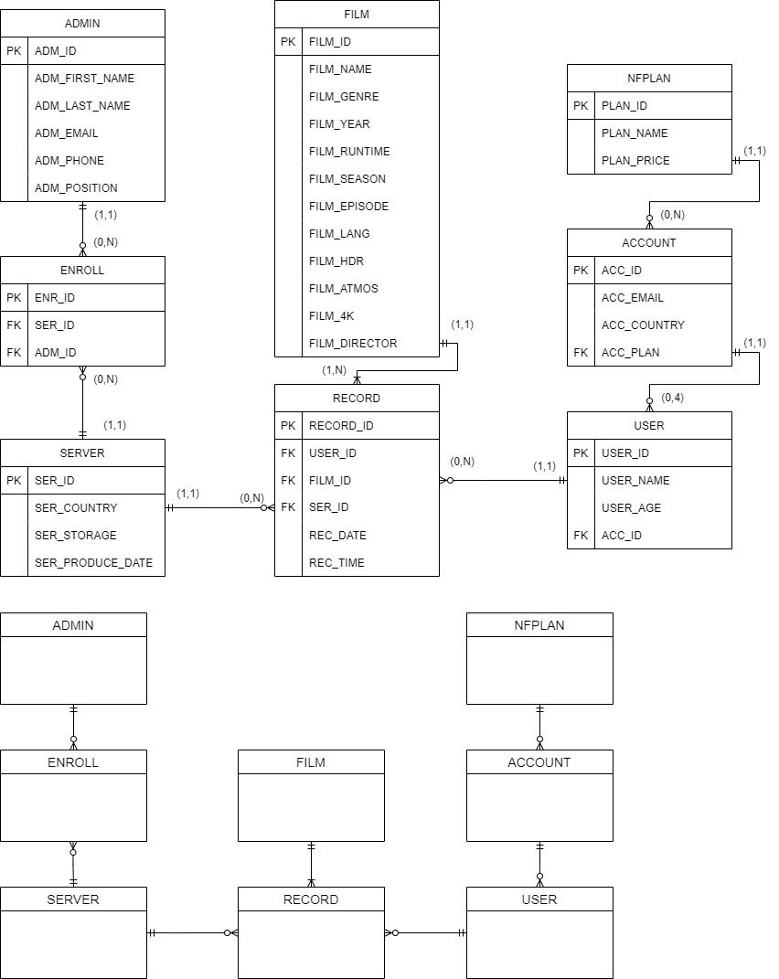
Figure 4.1 ER Diagram of Netflix Database

Foremost, we have designed the conceptual model of the Netflix database. Afterward, we developed 8 tables of database in Figure 4.1.

4.1.1 ADMIN
Attribute | Data Type | Not Null | PK / FK | FK Referenced Table | Unique
ADM_ID | INT | Yes | PK | / | Yes
ADM_FIRST_NAME | NVARCHAR | Yes | / | / | No
ADM_LAST_NAME | NVARCHAR | Yes | / | / | No
ADM_EMAIL | EMAIL | Yes | / | / | Yes
ADM_PHONE | INT | Yes | / | / | Yes
ADM_POSITION | NVARCHAR | No | / | / | No
Table 4.1.2 Data Dictionary of ADMIN

4.1.2 ENROLL
Attribute | Data Type | Not Null | PK / FK | FK Referenced Table | Unique
ENR_ID | INT | Yes | PK | / | Yes
SER_ID | INT | Yes | FK | SERVER | No
ADM_ID | INT | Yes | FK | ADMIN | No
Table 4.1.3 Data Dictionary of ENROLL

4.1.3 SERVER
Attribute | Data Type | Not Null | PK / FK | FK Referenced Table | Unique
SER_ID | INT | Yes | PK | / | Yes
SER_COUNTRY | NVARCHAR | Yes | / | / | No
SER_STORAGE | INT | Yes | / | / | No
SER_PRODUCE_DATE | DATE | Yes | / | / | No
Table 4.1.4 Data Dictionary of SERVER

4.1.4 RECORD
Attribute | Data Type | Not Null | PK / FK | FK Referenced Table | Unique
REC_ID | INT | Yes | PK | / | Yes
USER_ID | INT | Yes | FK | USER | No
FILM_ID | INT | Yes | FK | FILM | No
SER_ID | INT | No | FK | SERVER | No
REC_DATE | Date | Yes | / | / | No
REC_TIME | Time | Yes | / | / | No
Table 4.1.5 Data Dictionary of RECORD

4.1.5 USER
Attribute | Data Type | Not Null | PK / FK | FK Referenced Table | Unique
USER_ID | INT | Yes | PK | / | Yes
USER_NAME | NVARCHAR | Yes | / | / | No
USER_AGE | INT | Yes | / | / | No
ACC_ID | INT | Yes | FK | ACCOUNT | No
Table 4.1.6 Data Dictionary of USER

4.1.6 ACCOUNT
Attribute | Data Type | Not Null | PK / FK | FK Referenced Table | Unique
ACC_ID | INT | Yes | PK | / | Yes
ACC_EMAIL | EMAIL | Yes | / | / | Yes
ACC_COUNTRY | NVARCHAR | Yes | / | / | No
ACC_PLAN | NVARCHAR | Yes | FK | PLAN | No
Table 4.1.7 Data Dictionary of ACCOUNT

4.1.7 NFPLAN
Attribute | Data Type | Not Null | PK / FK | FK Referenced Table | Unique
PLAN_ID | INT | Yes | PK | / | Yes
PLAN_NAME | NVARCHAR | Yes | / | / | Yes
PLAN_PRICE | INT | Yes | / | / | No
Table 4.1.8 Data Dictionary of NFPLAN

4.1.8 FILM
Attribute | Data Type | Not Null | PK / FK | FK Referenced Table | Unique
FILM_ID | INT | Yes | PK | / | Yes
FILM_NAME | NVARCHAR | Yes | / | / | No
FILM_GENRE | NVARCHAR | Yes | / | / | No
FILM_YEAR | INT (4,0) | Yes | / | / | No
FILM_RUNTIME | Time | Yes | / | / | No
FILM_SEASON | INTEGER | No | / | / | No
FILM_EPISODE | INTEGER | No | / | / | No
FILM_LANG | NVARCHAR | No | / | / | No
FILM_HDR | BOOLEAN | Yes | / | / | No
FILM_ATMOS | BOOLEAN | Yes | / | / | No
FILM_4K | BOOLEAN | Yes | / | / | No
FILM_DIRECTOR | NVARCHAR | Yes | / | / | No
Table 4.1.9 Data Dictionary of FILM

4.2 Normalization

To avoid the redundancy of data and improve the data integrity, we have normalized our table from 1NF (Figure 4.2.1) to 3NF (Figure 4.2.2).

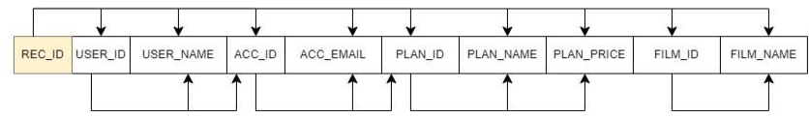Figure 4.2.1 Before the Normalization

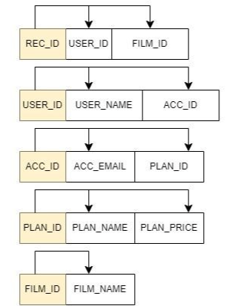
Figure 4.2.2 After the Normalization

Before Normalization, we can see that there is some attribute that is not only determined by REC_ID but also the USER_ID, ACC_ID, PLAN_ID, and FILM_ID. For example, REC_ID determines PLAN_NAME and PLAN_PRICE via PLAN_ID. PLAN_ID etc are their transitional dependencies in the whole table. Therefore, we decide to normalize it into 5 tables, which we could see in Figure 4.2.2 is more readable and clearer.

5. Queries and Entities

5.1 SQL Queries

The database system comes with some queries pre-designed to enable the Netflix team to have a clear overview of the effectiveness of the planning scheme and the film-watching trend. Besides, to ensure both the quality of film recommendations and the income of Netflix company.

5.1.1 Company Perspectives

Function:
To maintain the quality of servers and change the marketing scheme, to make profits.

Code 1:
Check whether the server needs to update. The code will first select all attributes in SERVER, then get the data that is in between the conditions.
SELECT *
FROM SERVER
WHERE ser_storage < 3000 OR ser_produce_date < '2017-01-01';
Table 5.1 Code 1.1

Result of Code 1:
The server on the list needs to upgrade and change.
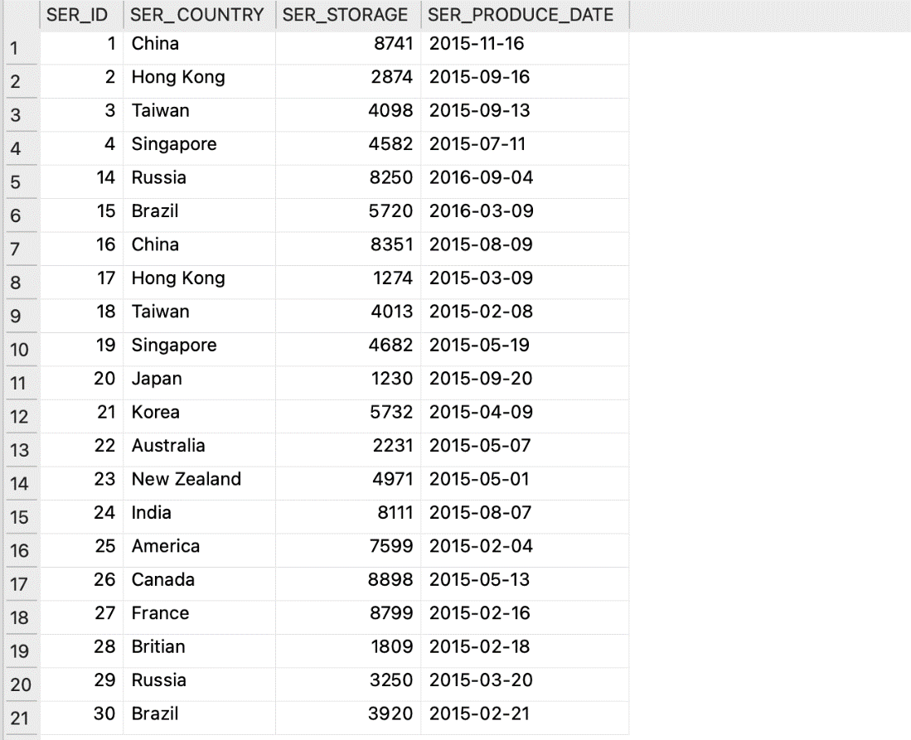
Figure 5.2 Result of Code 1

Code 2:
Knowing the total income from the user plan. The code let the sum of the plan price paid by each customer as the total income of the company.
SELECT SUM(NFPLAN.PLAN_PRICE)
AS 'Total Income'
FROM Account, plan
WHERE account.ACC_PLAN = nfplan.PLAN_ID;
Table 5.3 Code 1.2

Result of Code 2:
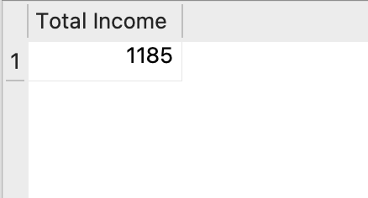
Figure 5.4 Result of Code 1.2
Code 3:
Which plan is the most popular for the Netflix user? The code let the plan name to ‘Plan’, the quantity of Plan subscribed as ‘Quantity’, the total income from the plan as ‘Income’, at lastly, group them by Plans.
SELECT NFPLAN.PLAN_NAME AS 'Plan',
COUNT(account.ACC_PLAN) AS 'Quantity',
COUNT(account.ACC_PLAN)*NFPLAN.PLAN_PRICE AS 'Income'
FROM Account, nfplan
WHERE account.ACC_PLAN = nfplan.PLAN_ID
GROUP BY account.ACC_PLAN;
Table 5.5 Code 1.3

Result of Code 3:
The distribution of the Plan, premium plan is the most popular one and can provide a discount to attract more people.
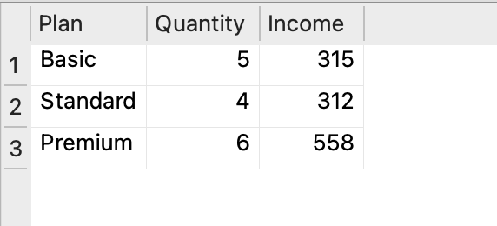
Figure 5.6 Result of Code 1.3

Code 4:
Which server has more records made by users? The code lets the server country as ‘Country of server’ and counts the quantity of the server as ‘Quantity’, at last to group by country and order by ‘Quantity’.
SELECT server.SER_COUNTRY AS 'Country of server',
COUNT(*) AS 'Quantity'
FROM server, record
WHERE server.SER_ID = record.SER_ID
GROUP BY server.SER_COUNTRY
ORDER BY COUNT(*);
Table 5.7 Code 1.4

Result of Code 4:
China, Hong Kong, etc has more record and can extend these servers.
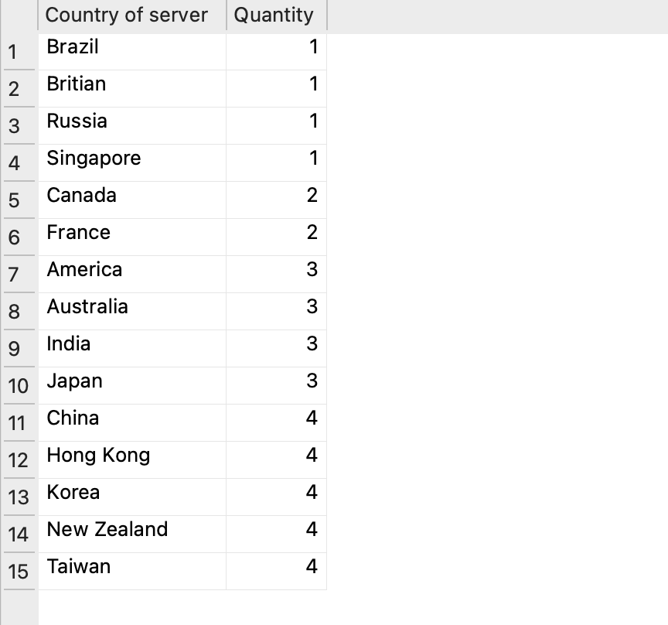
Figure 5.8 Result of Code 1.4

Code 5:
Managing human resources. The code is similar to Code 4, but the quantity changed from server quantity to admin quantity, at last group by server id.
SELECT server.SER_ID, server.SER_COUNTRY AS 'country',
COUNT(*) AS 'Quantity'
FROM admin, enroll, server
WHERE admin.ADM_ID = enroll.ADM_ID
AND enroll.SER_ID = server.SER_ID
GROUP BY server.SER_ID;
Table 5.9 Code 1.5

Result of Code 5:
See which server needs more and fewer human resources.
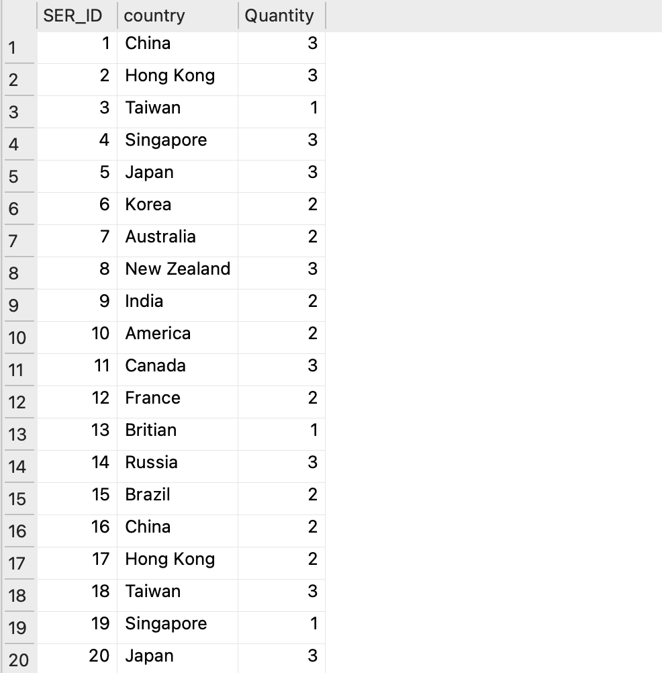
Figure 5.10 Result of Code 1.5(1)

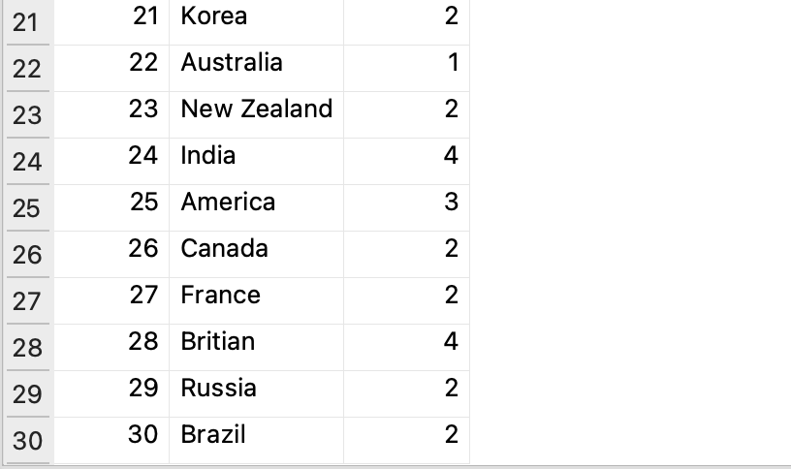
Figure 5.11 Result of Code 1.5(2)

Code 6:
Check whether the user used VPN or not. The code first counts how many records are there and counts how many records with the account country are not equal to the server country. We have set a case that:
SELECT count(*) AS Total,
SUM(CASE WHEN server.SER_COUNTRY <> account.ACC_COUNTRY THEN 1 ELSE 0 END) AS "the number of records which user does not use the server in their country"
FROM server, record, account, USER
WHERE server.SER_ID = record.SER_ID
AND record.USER_ID = USER.USER_ID
AND USER.ACC_ID = account.ACC_ID;
Table 5.12 Code 1.6

Result of Code 6:
87.5% of users not watching Netflix in their own country or used a VPN.
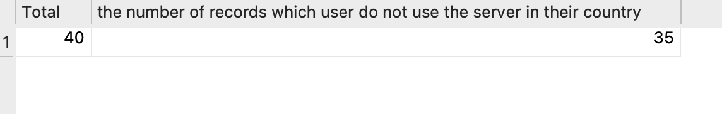
Figure 5.13 Result of Code 1.6

Code 7:
Using the following code to count film groups by language, genre, or year. The code first set film language to ‘Language’, then count how many films are corresponding to the following language.
SELECT film.FILM_LANG AS 'Language',
COUNT(*) AS 'Quantity'
FROM film
GROUP BY film.FILM_LANG
ORDER BY COUNT(*);
Table 5.14 Code 1.7

Result of Code 7:
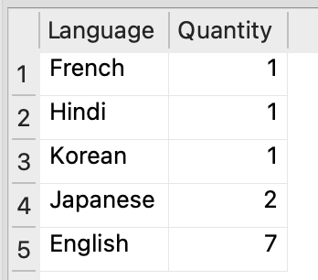
Figure 5.15 Result of Code 1.6

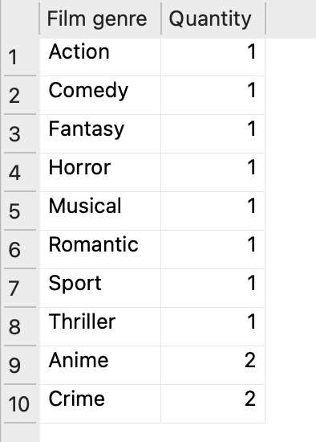
Figure 5.16 Result of Code 1.6 by Genre

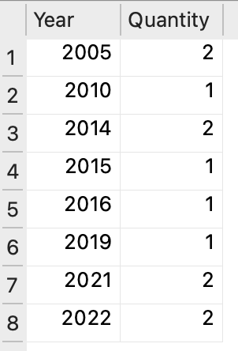
Figure 5.17 Result of Code 1.6 by Year

5.1.2 Customers’ Perspectives

Function: Knowing the user-watching experiences and watching preferences, to recommend the movie more accurately to the user.
Code 1:
Which movie is the least popular? The code first sets the name of the film as ‘Film name’, then finds which film has a record of fewer than 10 minutes.
SELECT film.FILM_NAME AS 'Film name',
COUNT(*) AS 'number of records which is lower than 10min'
FROM film, record
WHERE film.FILM_ID = record.FILM_ID
AND record.REC_TIME < '00:10:00'
GROUP BY film.FILM_ID;
Table 5.18 Code 2.1

Result of Code 1:
Only 3 of the film has user watch lower than 10 minutes, especially “Your Lie in April” which has more. These movies could consider taking off.
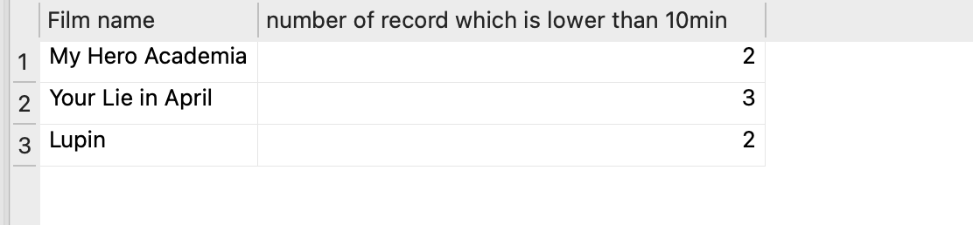
Figure 5.19 Result of Code 2.1

Code 2:
Which genre is the most popular? The code first set the genre of film as ‘Film genre’, then counts how many films there correspond to the genre.
SELECT film.FILM_GENRE AS 'Film genre',
COUNT(record.FILM_ID) AS 'Quantity'
FROM film, record
WHERE film.FILM_ID = record.FILM_ID
GROUP BY film.FILM_GENRE
ORDER BY COUNT(record.FILM_ID);
Table 5.20 Code 2.2

Result of Code 2:
Anime is the most popular genre on Netflix and can release more anime on Netflix.
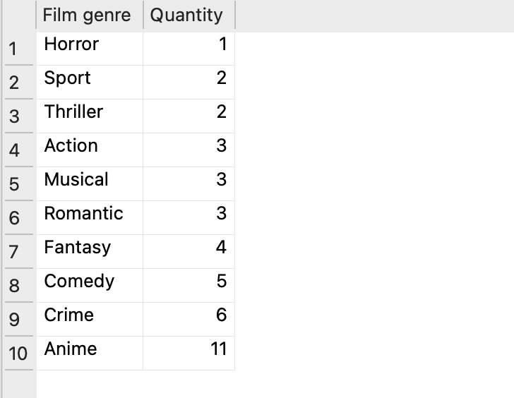
Figure 5.21 Result of Code 2.2

Code 3:
Knowing the target audience of each film. The code first lets the name of the film to ‘Film’, then finds the average age of the customer who watched this film based on the record.
SELECT film.FILM_NAME AS 'Film',
ROUND(AVG(user.USER_AGE),2) AS 'Average age'
FROM film, user, record
WHERE film.FILM_ID = record.FILM_ID
AND record.USER_ID = user.USER_ID
GROUP BY film.FILM_ID
ORDER BY AVG(user.USER_AGE);
Table 5.22 Code 2.3

Result of Code 3:
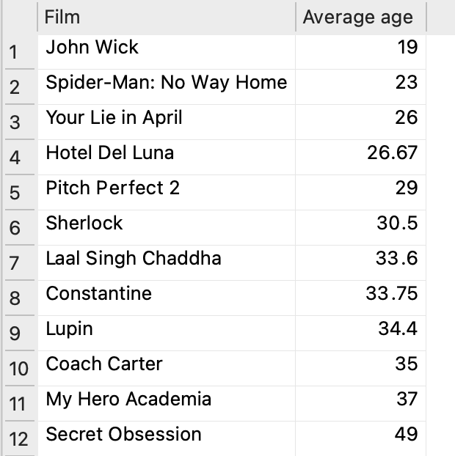
Figure 5.23 Result of Code 2.3

Code 4:
This code used to find the total amount of special effects is used in currently released films. Especially, we used the ‘CASE WHEN THEN ELSE END’ method to complete the counting of effects, we set value = int 1 when the boolean is TRUE and value = int 0 when the boolean is FALSE, at last, to sum up all the integers.
SELECT
SUM(CASE WHEN FILM_HDR='TRUE' THEN 1 ELSE 0 END) AS 'HDR Film',
SUM(CASE WHEN FILM_ATMOS='TRUE' THEN 1 ELSE 0 END) AS 'Dobly ATMOS Film',
SUM(CASE WHEN FILM_4K='TRUE' THEN 1 ELSE 0 END) AS '4K Film'
FROM film;
Table 5.24 Code 2.4

Result of Code 4:
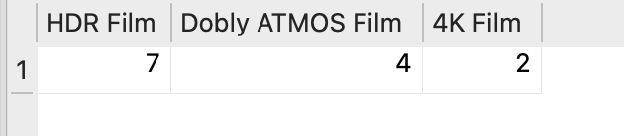
Figure 5.25 Result of Code 2.4

6. Conclusion

6.1 Summary of key findings

Our analysis revealed that Netflix has a diverse user base with varying preferences in terms of subscription plans, film genres, and languages. The most popular subscription plans, namely NFPLAN, were Standard and Mobile, highlighting the importance of optimizing the subscription plans to cater to the preferences of users. We also found from the data SERVER that users do not prefer to use servers located in their home countries, implying that users may have a habit of watching certain movies or films in a limited area. Therefore, Netflix should focus on enhancing server performance in these regions. The FILM library exhibited diversity in genres, languages, and release years, suggesting that Netflix should continue updating its content to maintain its diversity to a wide range of users. Finally, REC_TIME, a considerable number of viewers watched films for less than 10 minutes, warranting further investigation into the reasons behind this behavior.

6.2 Implications for Netflix

Our analysis implies there are several ways to conduct business strategies for Netflix. Firstly, the high number of Standard and Mobile subscription plans suggests that Netflix can adjust its pricing and features to attract more user groups. Moreover, Netflix should be suggested adding mobile-specific features or lowering the prices of premium plans to attract and retain customers. Second, Netflix must invest in server performance, stability, and availability in the home countries of its users to ensure a seamless streaming experience. Given the library's diversity of genres, languages, and publication years, Netflix should continue to acquire and produce content that appeals to its global audience. Netflix may be able to improve its content suggestion algorithms and user interface by resolving the problem of users viewing films for less than 10 minutes by analyzing user behavior and preferences.

6.3 Suggestions for further research

This report suggests various research possibilities. Firstly, we can deeply investigate customer preferences such as subscription, pricing, content availability, and streaming quality, which can help us optimize subscription quality. Also, we can find out more about user behavior, particularly the reason for varying watching times and whether they feel satisfied. Which can enhance user experience. Furthermore, knowing the relationship between server performance, customer satisfaction, and VPN usage could help Netflix make decisions about server investments and content distribution tactics. Finally, we can analyze Netflix’s competitive landscape, including rising trends and new marketing ideas, to ensure they stay informed about the new changes.

7. Acknowledgements
In addition to teaching us the concepts of database systems, we are very grateful for Mr. Tsui’s help. During this course, we learned how to design a data model, and query and get feedback which helped us solve problems when we were doing the project.

